(h3) CSC148 “Data sampling in an M1Q system”, Prof. Mitchell, Oct 13, 2019 Due date: Start of class Tues Oct 22

#1 Introduction

We have seen the strong effect of distributions on S behaviors such as arrival process, residence time, queue length, etc.
When a simulation project is in initial planning, effort/time must be allocated for sample data collection and analysis. The collected data is then statistically analyzed to determine relevant distributions
Data sampling, when properly done, is more time consuming and involved than commonly thought.
However, gathering such data is essential for choosing simulation distributions that best model the system’s behavior.

#2 Required Characteristics of the system to be sampled & Data collection guidelines

Introduction to this assignment was in the last part of module P2, where data collection was outlined.
The site you select for data collection must satisfy all of the following properties:
1 ) Each collection site must be a fast food drive through. No data is collected for any walk-up/walk-in customers inside the building, only the vehicles outside. Your “system” S is restricted to ONE outside vehicle drive through lane (must be a single lane) and the service windows that process customer orders. The number of service windows + order box at the site does not matter.
The data d must be collected in ONE collection time interval, NOT in 2 or more sessions.

2 ) You must collect several measurements (see Section#4, item 2.), per vehicle, for at least 100 Cj (anything less than 100 will not be accepted). One of the busier periods of the day is best for minimizing your data collection duration.

It is a good idea to “scout out” your chosen site, a day or two BEFORE the data collection to verify site suitability.
= > choose a collection location so that your line-of-sight covers the waiting line AND all drive through service windows.
SUGGESTION: it is reasonable to ask a friend to help during d collection (but this is not required) – the goal is to avoid missing data points or have confusion arise as you record data and observe system state.

3 ) Cj arrivals should be relatively rare - should be approximately, but a little more or less than, (one Cj)/minute during data collection. Such a rate produces 100 Cj in 2-3 hours of data collection. In addition, interarrivals should be independent of each other -
(arrivals should not be influenced by previous arrivals – although your own experience tells you that occasionally, a vehicle driver will decide not to join a queue because it is very long).
4 ) At some sites, it might be appropriate for you to get permission to do data collection. Whether permission is needed or not, be as inconspicuous as possible; the Cj should be unaware of what you are doing.

Here are two examples of drive-through systems -

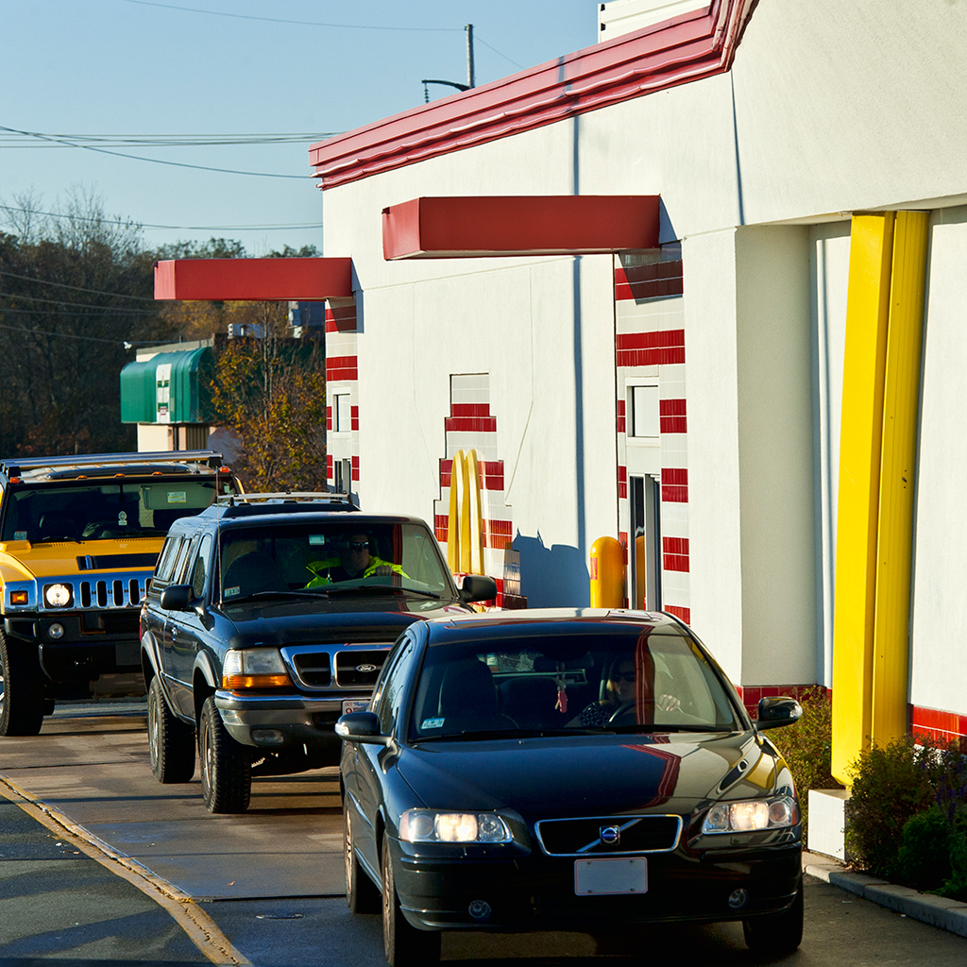
We said “vehicles”, didn’t we ?
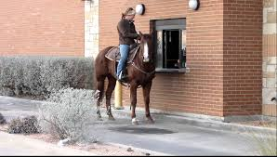

#3 Analyzing d

Construct a histogram of frequency of Cj arrival counts in fixed-sized time intervals (sis defined below) in the range
[d collection start time, d collection finish time] = duration of observation = T.

Arrivals Frequency Histogram construction from d

Time interval [0, T] is divided into equal “Sub Interval Sizes”, referred to as “sis”: [0, sis), [sis, 2*sis), [2*sis, 3*sis), etc.
That is, T is divided into int(T/sis) fixed-size subintervals.
Select a suitable sis value (such as 3, 4 or 5 – sis is data-dependent). Section #6 illustrates histogram shape sensitivity to sis size.

It is best when a histogram for a pmf
- has almost none, or no cells of height 0 (again, refer back to module P2), and
- has enough cells to provide the outline of the pmf (3 or 4 non-empty cells is too few to ascertain a shape)

The “best” sis value for your d might not be clear until trial-and-error produces a histogram satisfying a) and b) above.
Any tool you wish to use is ok for building and displaying histograms – this does not involve gpss histograms.
It is easiest to gather data d using a spreadsheet with plotting (for your histogram), and even better if it can evaluate the Poisson pmf

Let random variable “X” = {the number of Cj arrivals in a random interval of length sis}
Let n0 = (the number of intervals of size sis having 0 arrivals) in [0,T],
n1= (the number of intervals of size sis having 1 arrival) in [0,T] ,
: :
nk = (the number of intervals of size sis having k arrivals) in [0,T], and so on.
: :
Graph (example below) the “frequency histogram” of the points (k, nk), for k = 0, 1, 2, … as the pmf for X.

Example histogram construction: Suppose that your d indicates that 1 of the sis-length intervals had 0 arrivals, 3 of the
sis-length intervals had 1 arrival, 4 sis-length intervals had 2 arrivals, etc. Then, 3 histogram bars look like:
(This graph is constructed in the same way as graph G2 in Module 2, Slide#17)

Freq of k 4| x
3| x . . .
2| x
1|_________________________
0 1 2 . . . k . . . The possible arrivals counts in random intervals of size sis

#4 Hand In at start of class, Tuesday, Oct 22
ALL 4 sections of results below must be bundled into ONE FILE in .docx/.pdf format
ALSO, CLEARLY NUMBER EACH QUESTION AND part ANSWER in the order specified in the Hand In list

- A ) A word processed (not hand written) description of your site: location (street address), date the sample d collected,
and brief description of the nature/kind of service (establishment and approx. location, …);
B ) A picture of the line-of-site, exactly where you collected d (the line-of-sight must be suitable)
C ) The number of service centers “nSteps”, as defined below.
Service process notes: Define service “steps/stations”: order (O), pay (P), and getFood (G). IF O+P+G are all done at one
window/station, nSteps=1; IF O at one step, and P & G at same station, nSteps=2, ELSE O, P, G different stations, nSteps=3.
- Spreadsheet – the rows consist of the data for ALL successively arriving vehicles, having columns:
1 Cj#, (input or autoincremented: 1,2,3, etc.)
2 arrivalTime, (input) {means: time Cj joined line, if lineLength currently > 0, OR same as startServiceTime when S is idle}
3 L when Cj entered S (not including Cj), (input) {means: number of Cj is S when this new Ck arrives, but do not count Ck}
4 Cj startServiceTime, (input) = the instant that Cj finishes waiting (if any) and starts interacting with first window
5 Cj finishServiceTime, (input) = the instant Cj drives away with food/drink
Note on above two measurements: if your site is one for which a) there are at least 2 service windows and b) at least 2 consecutive windows are widely separated, then there can queuing among the separated windows that, technically is service wait time. However, for simplicity in this assignment, we include such waiting time as part of the service duration for Cj. (This will skew the service duration distribution, and likely produce a somewhat-strange looking service duration histogram).
6 Cj service duration (autocalculated) {needed for HandIn items 3. B ) and 3. C}
7 WCj (means Cj’s residence duration, NOT service duration), (autocalculated) {needed for step 4.}
- A ) 1 The equal-sized subinterval size sis, in units of minutes
2 The sample mean, x^ - obtained from d as: ((total number of Cj arrivals) / (number of sis intervals), where |sis| is your fixed
subinterval size, in minutes. Show the calculations for x^
B ) Histogram of frequency distribution of Cj arrivals, like the Frequency histogram construction at the end of section #3.
Use any plotting/graphing tool; no hand-drawn graphs accepted.
Keep a copy of d and your chosen histogram – these are needed for follow-on work on distribution fitting (outlined on next page)
C ) Histogram of service durations. As explained in class, if your ff has more than one service step, this histogram will NOT look like a typical exponential distribution pmf. It is, in fact, a sequence of n exponential services, n= number of service windows.
- Word processed write up (NO hand-written material) of a Little’s Law check on d (as demoed in Module P2), as follows:
A ) Calculate estimators for L^, λ^ (same as x^ of 3.A) above) and w^.
(Show HOW the values are derived/calculated; do not just write down 3 numbers) and
B ) Calculate the ratio L^ / (λ^ * w^)

#5 Handling the recently seen “rover” role at ff sites + frequency of arrivals pdf

The rover role
This section describes how to handle a recent (last 2 or 3 years) “feature” at ff sites, wherein a ff worker (refer to as a “rover”) comes out and does order or sales transactions with vehciles Cj that are queued for service. Although rover actions will disturb some of the service statistics, fortunately they do not interfere with the major objective of h3 – detailed study of the Cj arrival process.
The main principle is collect d only for Cj that remain in the single path from initial queuing to leaving S. Therefore, discard any Cj for which the driver (somehow) gets out of the line and parks off to the side. If your chosen site has any (even one) rover transaction with Cjs, apply the supplementary rules below that define service duration for those Cj involving a rover:
- Rover only takes an order outside, but does nothing else: start service when the order is taken; end that service when that Cj advances past the last window and drives away; all other measurements are same as in Hand In, item 2.
- Rover only takes payment but food is dispensed at a window (this is probably very rare). No Hand In part 2. changes are needed.
- Rover only brings food. Service finishes when the food obtained. No other measurements are changed.
- Rover does all functions: takes order, does payment, and brings food (this is also probably rare), but, if it occurs, service starts when the order is taken, and service finishes when food is dispensed.

(Even though Cj might still be stuck “in the line” after a rover transaction, the above definition 4 rules will only perturb Wcj values. This is because rovers will change service durations. This change does NOT impact the main focus of h3, that of doing a distribution fit of arrival frequency distribution (the “G2” graph). Fortunately, the Cj arrival process is not impacted by rovers.
HOWEVER, there will be one unfortunate effect of rovers: service durations, particularly artificially early service start times, will slightly increase Wcj values. This will likely affect the (Hand In Item 4) Little’s Law check, because avg(Wcj) will differ from the no-rover case.

The frequency of arrivals pmf

To repeat, the main objective of h3: a histogram, call it Hd) of frequency distributions of arrival counts in fixed-size intervals is constructed from d. After h3 is graded and returned, in a short assignment, the discrete pmf (probability mass function) represented by Hd will be “fitted” against a Poisson distribution’s pmf, where the mean of the Poisson distribution will be
the mean number of Cj arrivals in a random interval of length sis named x^ in HandIn part 3A), item 1

The physical nature of S is such that an Cj arrival rate of approx. 1 Cj/minute will result in an x^ value from d of approx. 3 (for sis = 3 min. Your x^ can be 2.x to 4.x, probably not exactly 3).
A very short add-on to h3 will be done AFTER graded papers are returned to do the following.
The Poisson distribution with mean α = 3 has probability of 2 arrivals in a random interval of length sis = prob(X=2) =
e^{-α} (α^{x} / x!), evaluated at α = 3 and x=2, giving 0.224 (Review: P2, Slide#22 – Poisson distribution family for varying distribution means)
Then IF your data d is a good fit to the above Poisson distribution, then the bar height in your Hd for x = 2 should be approx. 22% of the total bar height mass in your entire Hd. All other possible x values (0, 1, 3, 4, etc.) should have a similar relationship as for x=2.

Here is some Python source code and results for α = 3:
import math # Required external modules are accessed via the import statement
def peval(mean,x):
Results of peval function execution
=========================
0.049787068367863944 <= prob(X=0)
0.14936120510359183
0.22404180765538775 <= prob(X=2)
0.22404180765538775
0.16803135574154082 <= prob(X=4)
“”” Return the Poison pmf for mean “mean” at domain point x “””
return( math.exp(-mean) * math.pow(mean,x) ) / math.factorial(x)

meanVal = 3 # The mean of the Poisson distribution

# Display the first j values of the pmf
# Note: range(n) iterates over the ints 0, 1, ..., (n-1)
for j in range(5):
print(peval(meanVal,j))

#6 Factors influencing the shape of the pmf

Histograms below demonstrate the dependence of histogram “shape” for d on chosen sis value. The goal is to determine the sis value giving best histogram form.
Note that real sample d will not exactly match a theoretical distribution, so different sis values will probably result in one most-suitable histogram for d.

- First row: a busier S: 100 cj in 2 hours: subinterval division in cases: 40, 30, and 24. 40 subIntervals seems best – least ragged; no gaps.
- Second row: less busy S: 100 cj in 4 hours: subinterval division in cases: 80, 60, and 48 intervals. 48 subIntervals seems best – least ragged.
DETAIL for Second Row: mean λ = 100/240 = 5/12 cj/min, for sis=1 minute. Different sis choices give different means because the t.u. is increased for sis > 1 minute.
In order, the Histograms are for sis = 3, 4, and 5 min respectively. For example, for sis=3 min, there are 80 sis intervals in 4 hours, and the mean is thus 3*(5/12) =
15/12 = 1.25 cj/(3 min t.u.). Similarly, 4 and 5 minute sis values correspond to larger mean values of 1.66 cj/(4 min t.u) and 2.08 cj/(5 min t.u.).
By contrast, a busier system, say 100 cj in 2 hours First Row, can compare Histograms for sis = 3, 4, and 5 min sis values, for means 2.5, 3.3, and 4.2 cj/(sis size).
Here is python3 source code that generates one row of 3 histograms like First row, etc., described above:
""" poissonPlots.py - Histograms of Poisson-distributed variates. Version - Python 3.6.1 (v3.6.1:69c0db5, 2017 ... on Windows 10)
One histo. is plotted for each choice in a small range of subIntervals sizes for a specified observation time interval T. """
import numpy as np # Numerical processing module
import matplotlib.pyplot as plt # Plot library utility (quite similar to Matlab plotting)

def plotDisplay(plotData, title, xlabel, ylabel, binCount):
""" Histogram data normalization is set to False; binCount scales horizontal axis """
Function buildPoissonDistr’s call
np.random.poisson(p_mean, p_variateValues)
creates a specified number of random variable values that are distributed Poisson. This data simulates the actual data collected by each student in this assignment.

fig, axis = plt.subplots()
axis.hist(plotData, bins=binCount, normed=False)
axis.set_title(title)
axis.set_xlabel(xlabel)
axis.set_ylabel(ylabel)
plt.show(block=False) # Do not suspend execution after each plot is displayed

def buildPoissonDistr(p_mean,p_variateValues):
""" Calculate p_variateValues many Poisson-distributed values, mean = p_mean “””
return(np.random.poisson(p_mean, p_variateValues)) < -- Generates Poisson-distributed sample data

T = 120 # Duration of data observations (minutes)
ncj = 100 # A factor used to specify a total number of customer arrivals in [0,T], per plot
subIntervalSizes = 3 # Number of subInterval choices based on T (for Histo comparison)
numIntervals = [40, 30, 24] # Stepping value of: Number of equal-sized subintervals of T

for j in range(subIntervalSizes): # Iterate over 3 vs. 4 vs. 5 minute sub Intervals (of size sis)
pmfMean = float( (ncj/T)*(j+3) ) # Define next mean of the distribution of generated variate values
s = buildPoissonDistr(pmfMean,ncj) # s is type: <class 'numpy.ndarray'>
titleString = "Poisson arrivals in ", numIntervals[j], " fixed-size subIntervals, Mean: ", str(pmfMean)
plotDisplay(s, titleString ,"xi",
"xi frequency of occurrence", numIntervals[j]) # Display next plot

print("Finished Histogram plots for specified T, mean, and subInterval size comparisons ...")

